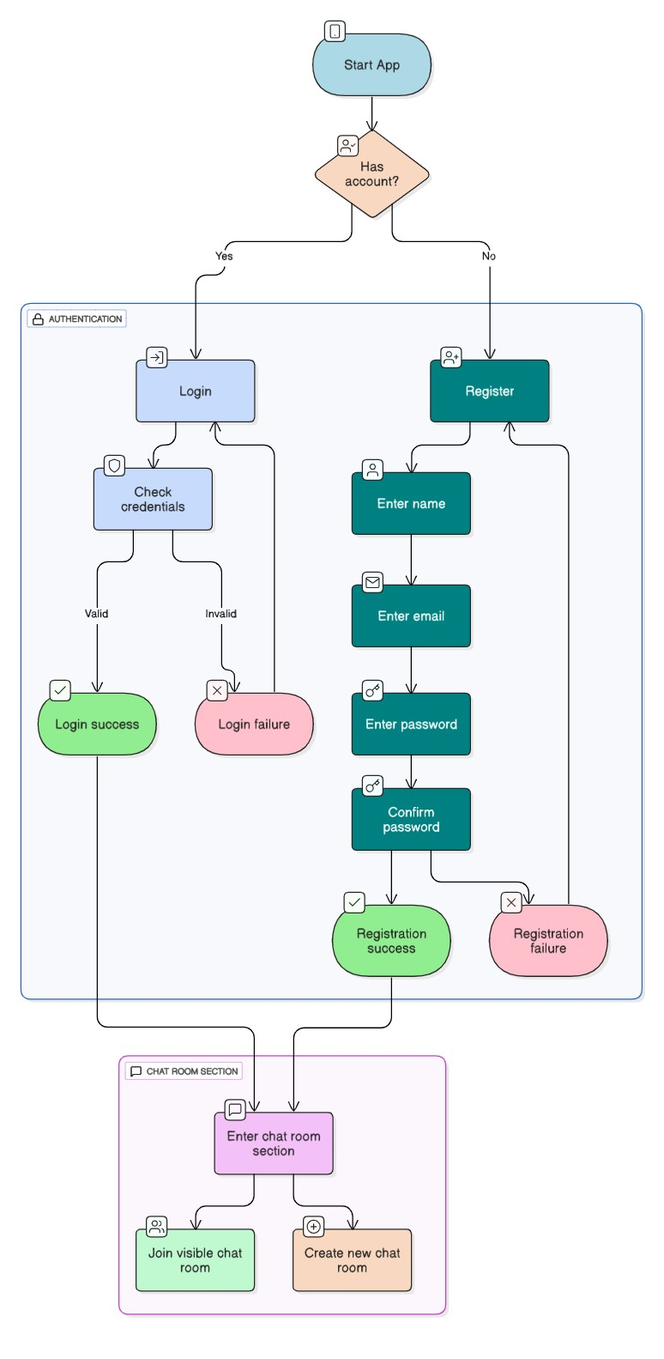
Project Design Phase

Data Flow Diagram & User Stories

Data Flow Diagram:

User Stories:

- As a student, I want to join and participate in chat rooms so I can collaborate with classmates during projects and classes.
- As a user, I want to receive real-time messages and notifications so that I stay up to date during ongoing conversations.
- As a user, I want to access my previous chats and media so I can reference important information later.
- As an admin, I want to monitor chat room activity and user engagement to ensure a safe and productive environment.

